**description of cOURSEWORK**

**OFFICE OF ACADEMIC AFFAIRS**

Reference No. : XMUM.OAA - 100/2/8-V2.0

Effective Date : 23 APRIL 2018



|  |  |
| --- | --- |
| Course Code | Web Site Design |
| Course Name | G0302 |
| Lecturer | Junaid Akram |
| Academic Session | 2021/02 |
| Assessment Title | Assignment (HTML & JavaScript) |

1. **Introduction/ Situation/ Background Information**

This assignment will focus to evaluate the students’ ability to implement web pages using HTML and JavaScript. It is intended to elevate the students’ knowledge and skills.

1. **Course Learning Outcomes (CLO) covered**

At the end of this assessment, students are able to:

CLO 1 Be able to create and maintain a simple web site using the current standard web page language.

CLO 2 Know how to use the foundation web site design language.

CLO 3 Know how to use a web editor.

CLO 4 Know a second web-based language which will be included to further enhance the web sites.

1. **University Policy on Academic Misconduct**
2. Academic misconduct is a serious offense in Xiamen University Malaysia. It can be defined as any of the following:
3. **Plagiarism** is submitting or presenting someone else’s work, words, ideas, data or information as your own intentionally or unintentionally. This includes incorporating published and unpublished material, whether in manuscript, printed or electronic form into your work without acknowledging the source (the person and the work).
4. **Collusion** is two or more people collaborating on a piece of work (in part or whole) which is intended to be wholly individual and passed it off as own individual work.
5. **Cheating** is an act of dishonesty or fraud in order to gain an unfair advantage in an assessment. This includes using or attempting to use, or assisting another to use materials that are prohibited or inappropriate, commissioning work from a third party, falsifying data, or breaching any examination rules.
6. All the assessment submitted must be the outcome of the student. Any form of academic misconduct is a serious offense which will be penalised by being given a zero mark for the entire assessment in question or part of the assessment in question. If there is more than one guilty party as in the case of collusion, both you and your collusion partner(s) will be subjected to the same penalty.
7. **Instruction to Students**

Write HTML with JavaScript embedded for the problems described in the tasks section. The due date for submission is 16 march 2020.

1. **Evaluation Breakdown**

|  |  |  |  |
| --- | --- | --- | --- |
| **No.** | **Component Title** | **Weight (%)** | **Percentage (%)** |
|  | Question (a) | 5 | 33 |
|  | Question (b) | 5 | 33 |
|  | Question (c) | 5 | 34 |
|  | **TOTAL** | **15** | **100** |

1. **Task(s)**
2. Create a simple webpage with the following elements and include a JavaScript (i.e. function) that will check the form if all the inputs are valid and given completely. You may leave the boxes empty or show the sample text (as shown in Figure) in the boxes. If all the inputs are given prompt a “Thank you” alert when the submit button is clicked. Otherwise alert “Please fill in all fields”. Form entry validation is compulsory.

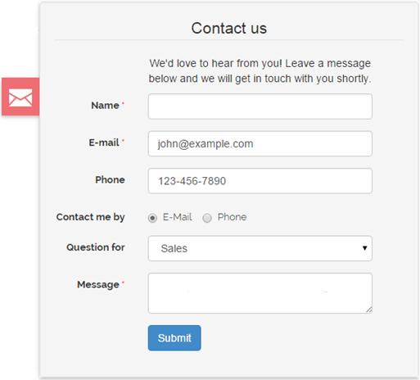

1. Create a simple webpage containing three images (e.g. a triangle, a square, and a circle). When an image is clicked an alert will appear with a text which shape was clicked, and when the image is clicked, it will change from image A to image B by using JavaScript. Example as show on images below.

**Before click:**



**After click:**

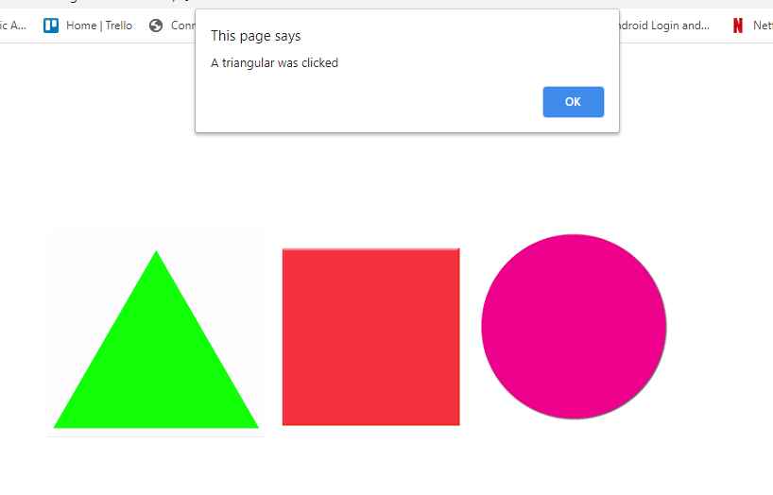

1. Create a simple webpage as follows. Users can tick which items they want and your application will prompt out the items user selected and a total amount of purchase.

Chicken Wings (RM 2.00)

Fried Chicken (RM 4.00)

Chicken Burger (RM 3.00)

**Lunch Selections**

Russian Solid (RM 8.00)

Pizza (RM 10.00)

Submit

**Submission to Moodle:**

After completion of this assignment take screenshots of your designed web pages and paste in MS word file including the Appendix form attached at the end of this assignment. Then save this word files as a pdf file and name it on you Student ID + Name.

Upload 2 files on Moodle, (Upload Limit: 20 MB)

1. PDF file of screenshots along with Appendix (Marking Rubrics).

2. The Zip file of all the source code files of your developed website, including html files, css files, images, txt files, etc. The Zip file name should also be on your Name + Student ID.

**APPENDIX 1**

**Marking Rubrics**

|  |  |  |  |  |  |  |
| --- | --- | --- | --- | --- | --- | --- |
| **Component Title** | **Assignment (HTML & JavaScript)** | | | **Percentage (%)** | **15** | |
| **Criteria** | **Score and Descriptors** | | | | **Weight (%)** | **Marks**  **%** |
| **Good**  **(5)** | **Average**  **(2.5)** | **Poor**  **(0)** | |
| Question (a) | Both HTML and JavaScript work very well. | Either HTML or JavaScript not working properly | Both HTML and JavaScript not working properly | | **5** |  |
| Question (b) | Both HTML and JavaScript work very well. | Either HTML or JavaScript not working properly | Both HTML and JavaScript not working properly | | **5** |  |
| Question (c) | Both HTML and JavaScript work very well. | Either HTML or JavaScript not working properly | Both HTML and JavaScript not working properly | | **5** |  |
| **TOTAL** | | | | | **15** |  |

**Note to students:**

Please print out and attach this appendix together with the submission of coursework